Presentation Structure

Concept foundation (tradition, influence)?

Wrist worn micro bit that tracks the users movements to count repetitions potentially providing details information surround arm position and wrist angles.

Benefit to user / why will people use the system?

Sensory information / ease of access. Is to provide users with seamless experience that tracks user data and provides feedback based on the users needs.

What is it similar to?

The blastbasketball replay is said to be a waist worn device that tracks the users vertile leap angles of spin moves and length of hangtime though trying to find any information on it was difficult 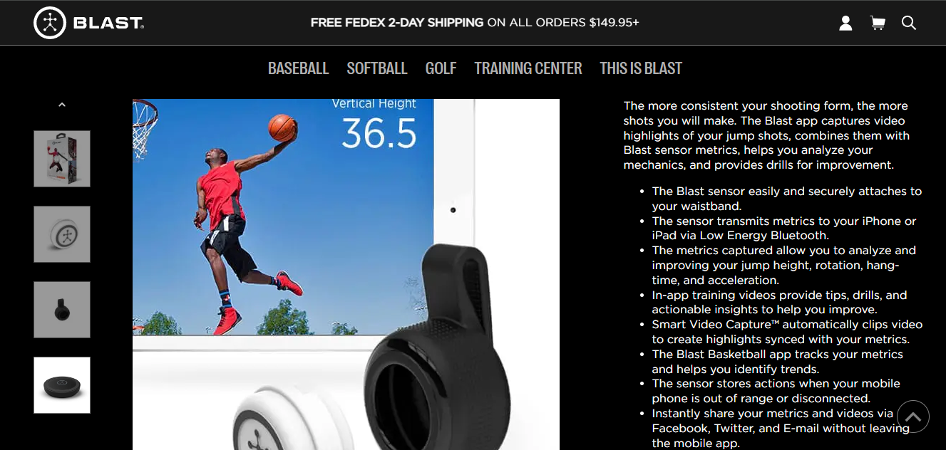

How is it unique?

My product is unique in that it does not require a mobile application at this stage and is also focused on the users dribbling as opposed to the users jump metrics or positioning

My device’s foundation was based on the belief that there is still a lot of potential in how technology can be implemented into sport and more specifically basketball. Designed on the needs of basketball players that want to improve and hone their skills and influenced by a similar wrist worn device in the fit bit. I have created a wrist worn device to assist users with their workouts by providing detailed and personalised statics based on the users’ movements. Using the built-in accelerometer in the micro bit v2. Information surround time, wrist angle, movement and tempo will be stored on the micro bit and relayed back to the user through visual and haptic feedback. Allowing users to focus on their sets providing a more concentrated practise. Like other basketball devices such as the “blast basketball replay” which is a waistband worn device that tracks the users vertical leap, hangtime and angle of spins. Together with its accompanying mobile and desktop app this device provides detailed data. However, this data does not represent the same movements I am working with. Another device is called shot tracker that has sensors watching the court and tracker worn by each player to create 3D visualisations and provide real time statistics during gameplay. Both devices do not cover the areas that I am focusing on which makes me believe my device may fill a niche role that is in demand. Along with not requiring an accompanying application the ease of access and immediate response make my device unique in the field